To link your Kroger Plus Card to the HAPNA rewards:
- Log in to KROGER.COM. (If you do not have a Kroger Card, you can register for one here.)
- Click on “Community” near the top right of the page for drop down menu.
- Click on “Kroger Community Rewards”

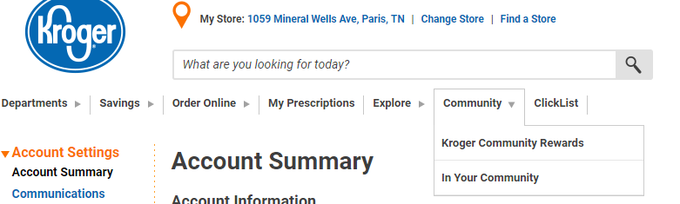

- Click on “View Your Rewards Details”
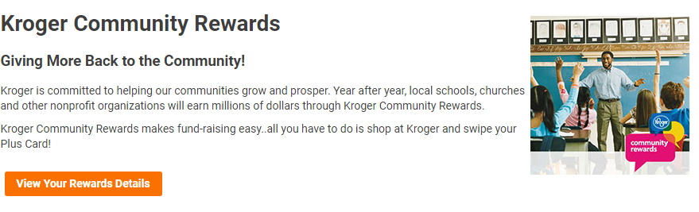
- You may be asked to locate your store, if so, then scroll down to Tennessee and locate the store in Paris. When you get to the box to enroll, the Organization Number is 21737.
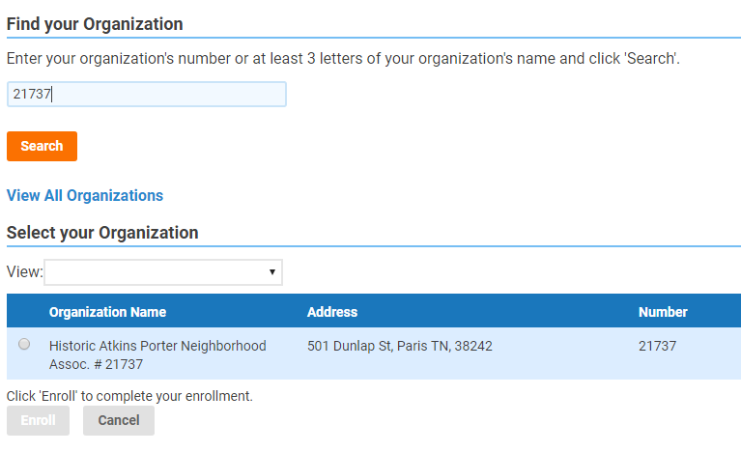

- That’s all there is to it!

- How does HAPNA earn rewards from your shopping at Kroger?
  - You enroll your Kroger card with the HAPNA organization # 21737
  - HAPNA automatically earns a rebate each time you use your Kroger card.
  - Household contributions are limited to $300 each quarter.
  - Minimum rebate to HAPNA is $25 quarterly and if $25 is not earned, then it will accumulate until it reaches the minimum.
  - Kroger mails HAPNA a rebate check following each quarter.

